iConnect Subpay 136175 Design Approach

# Project Overview

This enhancement will add the framework to support the collection of very basic Subsequent Premium data and the submission of the DTCC Sub file (30-35).   Some carriers will have subpay forms, others will not have any forms. FL will have a generic dataitems that can be used when carriers create their own subpay forms. A Template Form Can be provided outside of firelight, if requested by the client. If deemed needed by the industry, FireLight will also include any needed DOL data items, including a BIC indicator.

The only value e-submission of Subpays add to a carrier is if it can be processed with money settlement.  NIGOs for subpays are virtually non-existent because there are no forms.  Checks can be sent directly to the carrier and they deposit the funds and apply them to the standing allocations.  It was a resounding comment speaking with all of the carriers that the value of having subpay truly resided in money settlement, so they did not have to process checks.  Obviously, for a BD, it adds continuity of process, addition to the DTCC position files, Com file, etc.

Carriers will need to establish some rules at the product and state level for when the Subpay or maintenance changes are allowed.  Not all products and product types support Subpay.  For example, some products are single premium only and then Subpay would not be applicable.  FireLight will need to be able to support sub-pay only products.

As for the app side, we still need to have a drop down for product name and product type for the Subpay. Carriers need to know product type to route it correctly once at the carrier.

# Features/Requirements

* Implement the DTCC 30-35 file as an outbound feed. This is the same file layout as the App file, but it has different required/optional/conditional field elements. For example, a subpay is adding money to an already existing contract, so the contract details are required in a subpay file.



* + The APP and SUB records can be sent in the same file transmission to the DTCC.  We will designate either APP or SUB in the Contra Header using the Business Event Code of either “APP” or “SUB”.
* Implement a transaction option in the wizard to allow a menu selection of the new transaction option. This will be driven off of the organization level setting (see admin changes).
* The SSO requirements to support a subpay will need to allow for additional contract level details to be pre-filled into the application.
  + The 508 Acord TransType can be used to launch directly into a Subpay order.
* Implement money settlement, iconnect 134970, as a pre-requisite to this WO.
* Implement the delayed use of the 103, iconnect 135628, as a pre-requisite to this WO. The clients will need to be able to SSO into FL and then select the Subpay option. The data sent in the SSO will need to be available for the Prefill
* Data elements needed to capture on the Subpay form include:
  + Policy Number
  + Owner Name
  + Product Type and Jurisdiction (Optional)
  + Qualified Account indicator
    - Tax year if qualified money
  + Additional Amount – carriers can code minimum and maximum rule on this field.
  + Funding source (ACH, Wire, Brokerage Account) – These options will need to be driven by the organization level. Must be able to support multiple funding sources.
  + If money settlement is being utilized, we will need to pull the carrier code for the settling firm.
    - Since the Subpay product may not exist on FL, we need a new organization level carrier code that can be the default code to use for money settlement.
  + Implement a copy of all of the application email templates for Subpay email templates. This will allow clients to have different emails for Subpay transactions.

# Use Cases / Workflow Changes

Implement a new form to drive Subpay questions. Use these questions to prefill into the Sub file.

1. Initiate order on client side, SSO into FL with a 508 that contains the contract and policy data and land directly in the Subpay form for that carrier. Use this data to prefill into the subsequent premium form.
2. Initiate order in FL. In this case, the SSO will remain a 103. The user will be able to select the option for Subsequent Premium. Because we are also implementing the delayed use of the 103, the data sent in the 103 should prefill into the subpay form.
   1. Use this data to prefill into the subsequent premium form.

# Admin Changes

* Ability to approve transaction types for each product with the following options: Application, SubPay, Pre-Sale, Post Issue.
* Ability to enable/disable transaction type by role code on the Groups tab in the Admin tool. The option to ‘Disable Create Applications’ already exists on the group options, but new options will be added for ‘Enable Create Subsequent Payment’ and ‘Enable Create Post Issue’.
* If the subsequent payment transaction type is not selected on the products tab for a particular product type, the product type will not be included in the product type drop-down in the ‘Create a subsequent payment’ in the App Portal
* If the group the user belongs to does not have the transaction type enabled, the transaction type will not be included in the available types in the ‘New Application’ drop-down menu.
* Subsequent payment transactions can be added to an existing product by including the maintenance forms in the selling agreement as part of a specific maintenance type package. It can also be used more generically by creating a subsequent payment product
* Admin ad-hoc reports—Agent Report and Agent Activity Report—will be modified to list transaction type to allow for tracking of application, sub-pay, and post issue transactions
* Activity report modifications/additions
* Product Line Submission Summary report now contains counts for only new business applications
* Detailed Submission Report by Channel now contains transaction specific counts
* An additional transaction column has been added to the detail reports- Detail Submission, DTI Detail Submission, Detail Decline Sign, Detail Submission by Channel, Detail Submission by Carrier, Pending Orders, Pending Deletion, Pending Purge, and Purged Applications.
* Additional submission summary report listing submission counts by transaction type added
* If money settlement is being utilized, we will need to pull the carrier code for the settling firm.
  + We will continue to support the existing ability to pull in the DTCC Carrier code from the SSO, Provider, and rules engine.
* Something to consider is how the new transaction types are defined/managed in a multi-carrier environment because we can have a distributor who wants subpay but the carrier that doesn’t support subpay, or supports subpay but not money settlement.
* Selling Agreement – No change. Products will still be part of the selling agreement. This will allow us to control the availability in a multi-carrier environment. We can have a distributor who wants subpay but the carrier (AXA) doesn’t support subpay, or supports subpay but not money settlement.

# App Changes

New Transaction Type Selectable when creating the app.

# Integration Changes

* The inbound SSO will have the 508 Acord TypeCode. If the 508 is passed, we will know they want to perform a subpay on the application.
* Clients wanting to support the subpay file will need to have an integration change to send the 30-35 to the DTCC for subpay transactions.
* Carriers wanting to support Subpay with money settlement for their clients will need to ensure their carrier code is listed in the new Organization setting.

# UI Mock Ups

*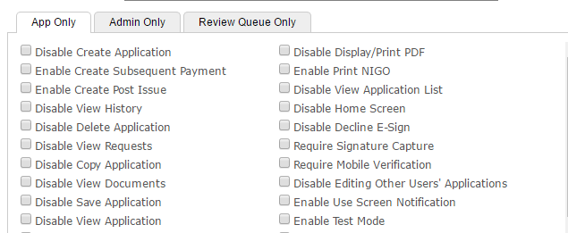 The creation of transaction types can be enabled/disabled by group role code in the Groups tab of the Admin tool. Previous option ‘Disable Create Application’, and new options for ‘Enable Create Subsequent Payment’ and ‘Enable Create Post Issue’ gives organizations the flexibility to limit the application type allowed.*

Product *transaction type approvals for new application, presale, subpay, and post issue*

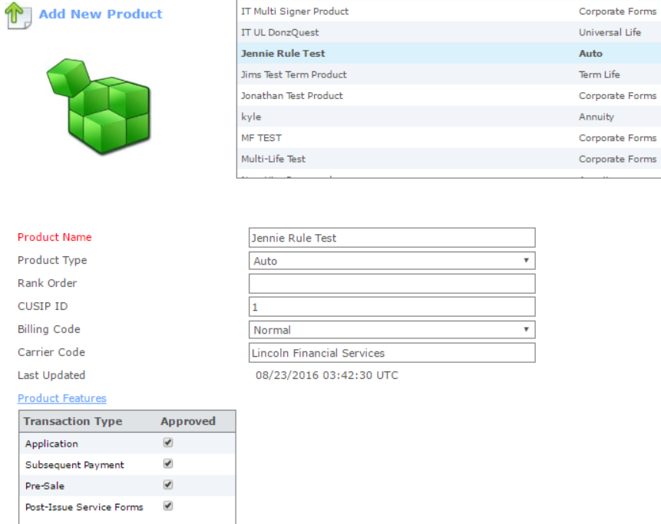

### App Portal

New sub-menu for transaction types will be enabled when multiple transaction types are approved for the logged in user

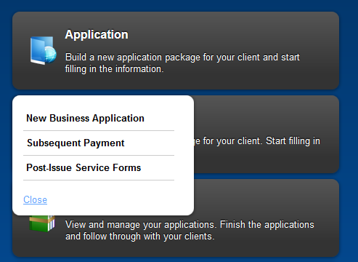

# 

# 

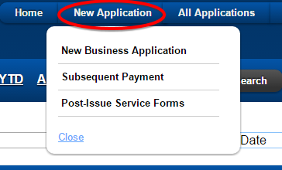

New Package Type

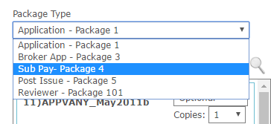Below and attached is a sample form that carriers can use to collect the data for Subpays.



# How to Enable and Use This Feature

There is not an additional license fee. If a client already has Annuity Line of Business active, this is an added transaction at the cost of $3.00 per transaction. Existing clients will need an addendum to their contract to support this new feature and reference the new fee.

Clients interested in this project will need to work with their PM to update their backend feeds to include this file.

The organization code setting will need to be activated to have the option of FireLight. Products will need to be added for Subpay transaction.

# Areas Impacted

|  |  |  |
| --- | --- | --- |
| System Area | Yes | Comment |
| Admin Tool |  |  |
| * Form Library | x |  |
| * Design Forms | x |  |
| * Profile Administration | Y | Products: Add New Transaction Types  Groups: Enable Subpay CheckBox Added  Packages: Add New Package Type “Sub Pay” |
| * Reports | x |  |
| * Deployment | x |  |
|  |  |  |
| FireLight App | x | New transaction type called subsequent Premium |
| * New Application | x | Add New Transaction Type Selection on New Application. |
| * Edit Application | x | Pull only packages related to Sub Pay. |
| * Signature Process |  |  |
| * Review Queue |  |  |
| * Manual Review |  |  |
| * User Preferences |  |  |
| * Inbound Integration | x | Account for 503 Accord Transactions. |
| * Outbound Integration | N | Outbound 503 could be added in the future, but not supported in initial release. |
| * PDF Generation |  |  |
| * Email System |  |  |
|  |  |  |
| FireLight Console |  |  |
| * Windows |  |  |
| * iOS |  |  |
|  |  |  |
| Other Systems |  |  |
| * DTCC Integration | x | Create Subpay document to send to the dtcc. Updates in DTCC entity. |
| * Commission Netting |  |  |
| * Activity Reporting | x |  |